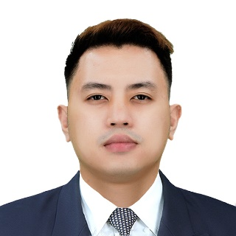­­



Erlangen, Langfeldstr 35, DE



+49 1747827269



jdreyes24@gmail.com



linkedin.com/in/jdreyes24

**EDUCATION**

**BS in Information Technology** **2017-present**

AMA University and Colleges

Web Development, Software Engineering, Database & Security

**Computer Technology** **2005-2007**

Asian Institute of Computer Studies

Computer Programming, Interfacing, Systems, Network & Hardware

**JOMAR OLIVER REYES**

E-Commerce and Marketing

◼◼◼◼◼

Softwares and Hardwares

◼◼◼◼◼

Systems and Networks

◼◼◼◼◼

Communication (VA, Social Media)

◼◼◼◼◼

Programming (PHP, MySQL, Etc.)

◼◼◼◼◼

Technology (OS, Cloud, Web Dev.)

◼◼◼◼◼

HOBBIES

SKILLS

CONTACT

LANGUAGES

ENGLISH

◼◼◼◼◼

ARABIC

◼◼◼◼◼

GERMAN

◼◼◼◼◼

Success-driven and results-focused with more than 11 years of experience in the IT industry. Efficient performance with a strong background in any kind of technical support and maintenance within systems, web applications, data center, network, hardware, software, security, users and clients‘ virtual assistants. Workstations, servers, web clients, databases, systems, and network administration. Encompassing in problem-solving, process improvement, software testing, vendor relationships, load balancing, and scalability. Functionality & implementing technology-based solutions for business problems, along with standards and procedures. Communicate with technical and professional people verbal and written, effective teamwork, time management, organized and willing to learn new things for my career growth.

**IT - Support Engineer** **2007-2012**

Imaginary Friends Studio, Inc. - Philippines

Deploying, configuring, managing and maintaining of IT Systems, Network Infrastructure and provide hands-on training for the users.

**EXPERIENCE**

**IT - Systems Engineer** **2018-2020**

Velocity Solutions, Inc. (MSP) - Philippines & Hong Kong

Assisting/Resolving the clients’ requests & issues on Windows/Mac/Linux desktop, laptop and servers thru remote and virtual environment.

Setup, implement, manage and monitor IT Systems & Infrastructure.

**IT - Support Specialist** **2013-2017**

Wallan Trading Co. & GAMA/KAMCJ – Saudi Arabia

Provide technical support via telephone, email, tickets and remotely

T-shoot & resolve a wide range of software, hardware & network issues.

**IT - System & Network Administrator** **2012-2013**

Torch Film Productions Studios, Inc. - Philippines

Responsible for day to day operations and administration of IT Infra.

Secure the systems, applications and maintain network stability.